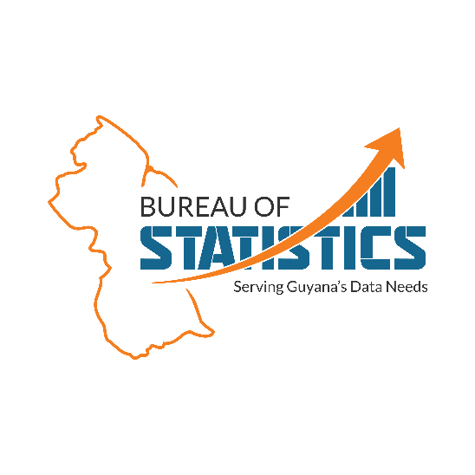

|  |  |
| --- | --- |
| **Job Title** | **Human Resources Clerk** |
| **Department** | Human Resources |
| **Reports To** | Human Resources Officer |
| **Location** | 34 Main & Hope Streets, South Cummingsburg, Georgetown, Guyana |
| **Objective** | The Human Resources Clerk is responsible for assisting the HR department in various administrative tasks such as maintaining and updating personnel records, providing support in recruitment and selection processes, training and development. |
| **Job Responsibilities** | * Assist in the preparation of memorandums and letters. * Assist with the recruitment process by preparing interview evaluation sheets, folders, etc. * Conduct research regarding training and development. * Assist with the scheduling and coordination of in-house and external training programmes, sensitisation, and employee engagement sessions. * Assist with Human Resource matters; and processing of documentation according to defined rules and procedures. * Assist with planning the annual Work Study and Internship Programmes. * Update the training database with relevant training providers, materials, training activities, programmes, and attendance, etc. * Maintain Human Resource leave record. * Prepare monthly attendance report. * Performs other related duties. |
| **Job Specifications** | * Five (5) subjects CXC including English A and Mathematics (Grades I to III). * Basic knowledge of Microsoft Office Suite and office equipment such as printers, scanners, etc. |